

**NWAS Leadership Framework**

**Be Think Do self-assessment**



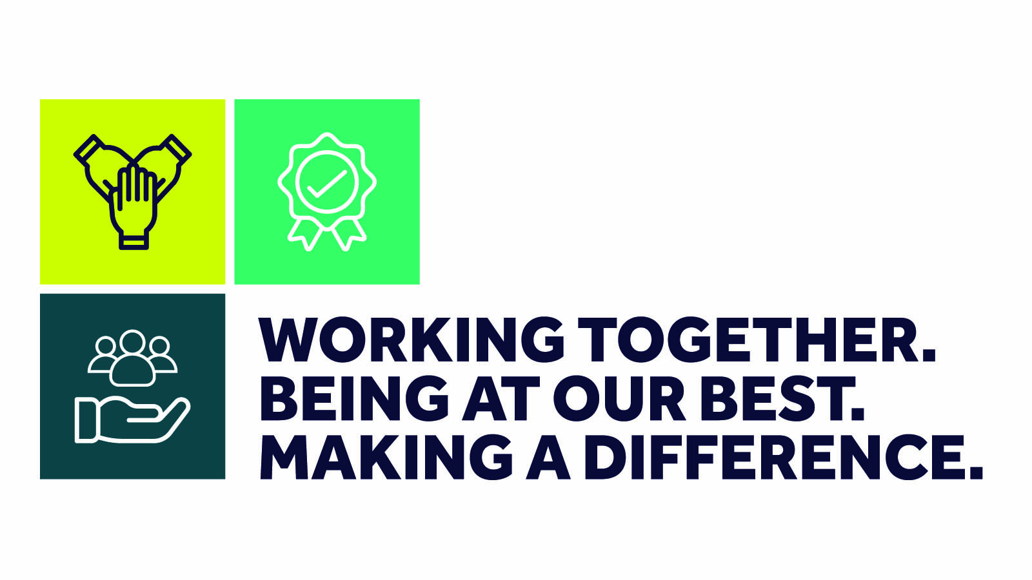**Version 3 – April 2021**

**Self-assessment against Be Think Do – measuring the behaviours of our leaders**

The Be Think Do self-assessment helps you to reflect upon your leadership style and approach.

Like a 360 tool, you can complete this yourself and also share with your team/peers/colleagues to help identify what you do well, along with any blind spots and development areas.  Perhaps ask someone to collate the responses for you.

Try not to use the performance criteria too rigidly; this is not about creating a tick list but about an honest reflection of your leadership approach:

* **Excel:** what do you excel at?
* **Good:** what are you good at but there’s still scope for improvement?
* **Could do better:** what could you do better?
* **Don’t/no:** what are the areas that you currently don’t do or have never considered before?

Are there any themes? Think about your next steps…

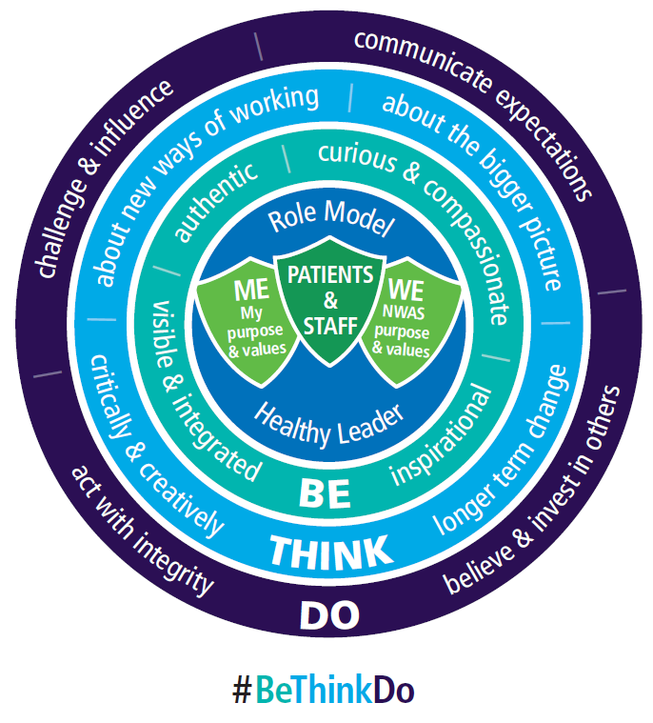

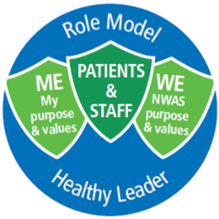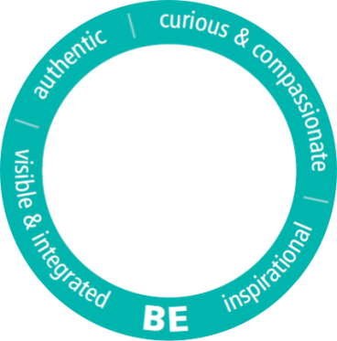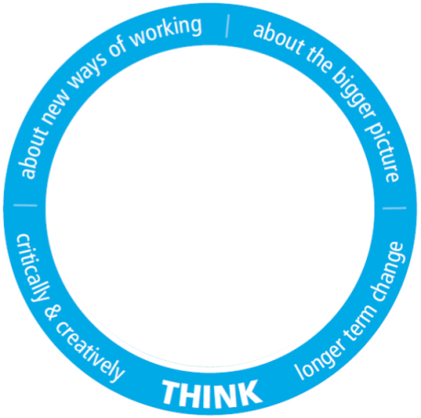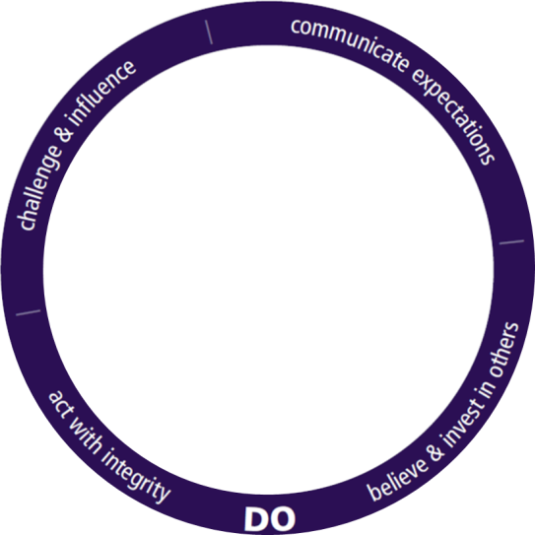

|  |  |  |  |  |  |  |
| --- | --- | --- | --- | --- | --- | --- |
|  | **Be** | **Excel** | **Good** | **Could do better** | **Don’t / no** | |
| **Authentic** | Aware of own style, seek feedback and review own approach |  |  |  |  | |
| Approach leadership situations with consistency |  |  |  |  | |
| Operate with objectivity and fairness whilst keeping the bigger picture in mind |  |  |  |  | |
| Operate with transparency and explain motives / direction of travel |  |  |  |  | |
| **Visible and integrated** | Communicate regularly, effectively and honestly |  |  |  |  | |
| Invest in and maintain mutually beneficial relationships – proactively connect with others |  |  |  |  | |
| Proactive in working across boundaries seeking views and perspectives from other areas of NWAS |  |  |  |  | |
| Encourage self and others to integrate through different means of communication (inc. social media) |  |  |  |  | |
| **Curious and compassionate** | Engage with others in an emotionally intelligent way |  |  |  |  | |
| Align leadership style to NWAS values |  |  |  |  | |
| Respond with empathy to personal and difficult subjects |  |  |  |  | |
| Seek views of others to inform situations – don’t follow own approach without understanding others’ views |  |  |  |  | |
| Encourage innovation and ideas (with self and others) to improve quality |  |  |  |  | |
| Ask open questions to ascertain quality information to inform an objective view point |  |  |  |  | |
| **Inspirational** | Lead with a positive and solution-focussed approach |  |  |  |  | |
| Demonstrate courage and conviction in decisions and direction |  |  |  |  | |
| Share stories and examples to bring the vision to life for others, instilling in others a clear sense of purpose |  |  |  |  | |
| Be a role model to others – go about the working day with the right attitude and behaviours |  |  |  |  | |
| Demonstrate resilience and maintain a positive mind-set and support others through tough times |  |  |  |  | |
| My reflections: | | | | | |

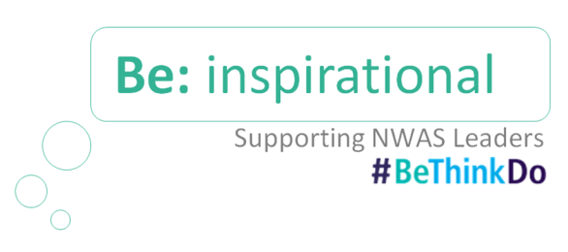

|  |  |  |  |  |  |  |
| --- | --- | --- | --- | --- | --- | --- |
|  | **Think** | **Excel** | **Good** | **Could do better** | **Don’t / no** | |
| **About new ways of working** | Ensure clarity of thoughts and manage ambiguity whilst making plans |  |  |  |  | |
| Work collaboratively and with courage to explore new and possible ways of working |  |  |  |  | |
| Role model and investigate new ways of working, holding others to account to identify solutions |  |  |  |  | |
| **About the bigger picture** | Think across the wider system to inform and shape future direction for the greater good |  |  |  |  | |
| Understand the meaning and significance of a wide, varying range of information and present with clarity for others |  |  |  |  | |
| Dissect personal biases and opinions from important information before making a decision |  |  |  |  | |
| Aware of how decisions affect other individuals and teams across NWAS |  |  |  |  | |
| **Critically and creatively** | Spot patterns and their relevance when analysing information and use this to inform direction and purpose |  |  |  |  | |
| Objectively evaluate information from numerous sources to draw sound conclusions |  |  |  |  | |
| Ensure that proposals, direction and conclusions are backed by solid data and logic |  |  |  |  | |
| Actively engage in self-examination and self-correction where appropriate |  |  |  |  | |
| **Longer term change** | Encourage the team to think about the bigger picture and long term goals |  |  |  |  | |
| Aware of NWAS strategic direction and keep a line of sight when making decisions |  |  |  |  | |
| Maximise opportunities to bring the bigger picture into conversations with others (eg. 1:1s, team meetings) |  |  |  |  | |
| Celebrate innovation and ideas for change whilst taking a balanced approach between supporting change initiatives and ensuring stability |  |  |  |  | |
| My reflections: | | | | | |

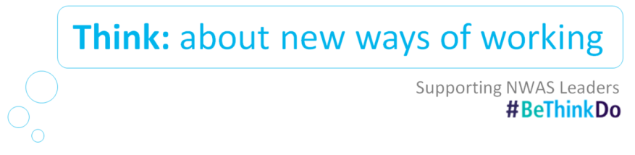

|  |  |  |  |  |  |  |
| --- | --- | --- | --- | --- | --- | --- |
|  | **Do** | **Excel** | **Good** | **Could do better** | **Don’t / no** | |
| **Believe and Invest in others** | Continually scan the workplace for opportunities to celebrate success, support others to improve and build on best practice |  |  |  |  | |
| Regularly provide valuable feedback to team members through formal and informal opportunities |  |  |  |  | |
| Objectively spot high potential / capability gaps within the team and, through a coaching conversation approach, identify development solutions to build on / improve the situation |  |  |  |  | |
| Actively support the development of others through identifying learning opportunities using the 70:20:10 principle |  |  |  |  | |
| **Communicate expectations** | Keep team well informed and knowledgeable about what is going on in NWAS and across the wider system |  |  |  |  | |
| Clearly articulate expectations and define what ‘great’ looks like |  |  |  |  | |
| Recognise and reward performance and results, making connections to the trust objectives |  |  |  |  | |
| **Challenge and influence** | Use a coaching conversation approach to allow individuals to think about solutions for themselves |  |  |  |  | |
| Confidently challenge colleagues and team members when NWAS values are not being displayed |  |  |  |  | |
| Face difficult conversations when necessary – care about what happens next |  |  |  |  | |
| Challenge unacceptable behaviour using relevant trust policies |  |  |  |  | |
| **Act with integrity** | Use own values to drive the right behaviours to support own personal brand and the wider reputation of NWAS |  |  |  |  | |
| Openly recognise and share own experiences of successes / mistakes with the team and colleagues so that others can relate |  |  |  |  | |
| Deal with conflict in a calm and mindful way, maintaining the dignity of others |  |  |  |  | |
| Engage with the team before making decision which may affect them. Genuinely listen to their views and perspectives |  |  |  |  | |
| My reflections: | | | | | |

